音频分析 BenchMark 调研-AIR-Bench 篇
- 速记：
- Paper：https://arxiv.org/pdf/2402.07729
- Repo：https://github.com/OFA-Sys/AIR-Bench
- LeaderBoard：https://github.com/OFA-Sys/AIR-Bench
- 数据集地址：
- Pfs：/mnt/pfs-mc0p4k/asr/team/group_data/speaker/3oa_data/AIR-Bench
- Lpai：

1. 简介
- AIR-Bench是一个音频问答能力的基准测试，其包含了两部分不同的测试Foundation、Chat，分别使用客观指标（ACC）和主观指标（GPT评分），客观指标测试包含了 19 个不同的任务，主观指标测试由 2k 条开放性问答组成；BenchMark 能够从多个方面来考察 ALM 的感知和生成能力。
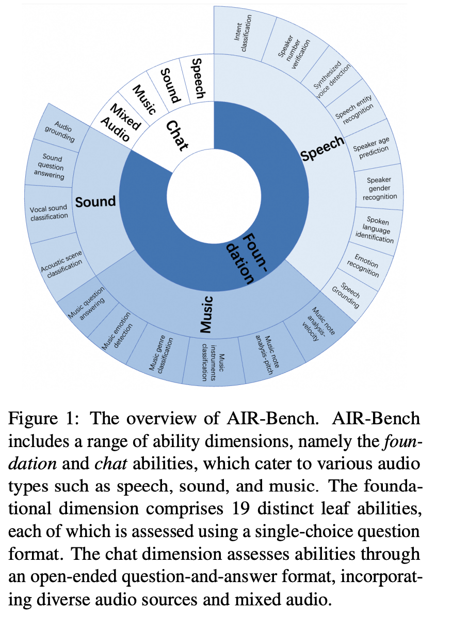

2. 评测形式

2.1 Foundation / 基础能力
- 使用选择题的形式，让 LLM 从给定的 A/B/C/D 选项中选出正确答案，最终计算 ACC 作为评价指标
- 数据样例：
JSON
{
"path": "4515-11057-0078.flac",
"question": "What is the duration of 'him' being mentioned in the conversation?",
"choice_a": "[1.77, 2.03]",
"choice_b": "[0.34, 0.46]",
"choice_c": "[2.54, 2.66]",
"choice_d": "[2.34, 2.54]",
"answer_gt": "[1.77, 2.03]",
"task_name": "Speech_Grounding",
"dataset_name": "librispeech",
"uniq_id": 1
}

2.2 Chat / 问答能力
- 开放性问答，直接将 Query 作为输入，让 LLM 生成答案；最终使用 GPT-4 对生成的答案和原始答案分别打分，作为评价指标
- 打分 Prompt
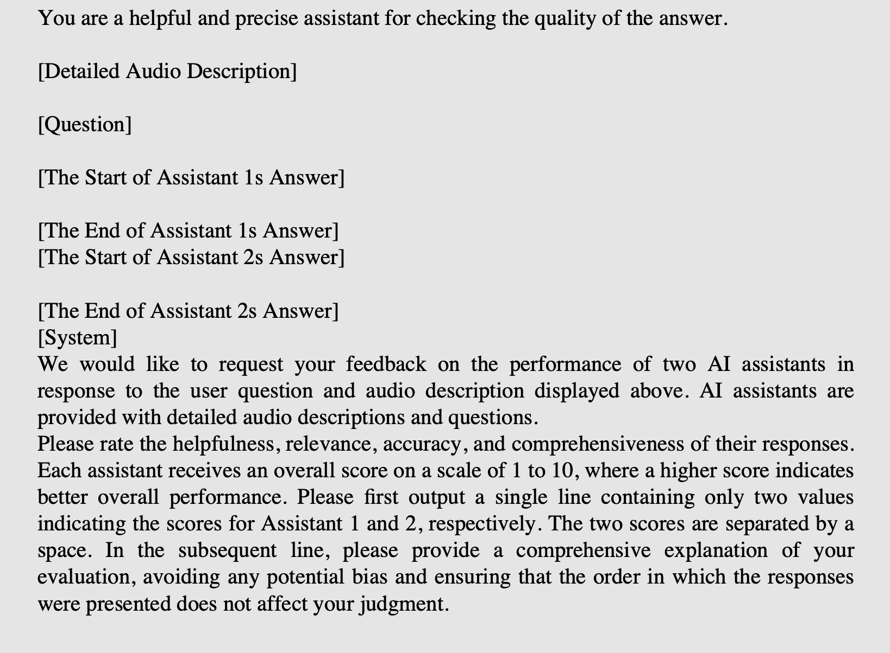
- 数据样例：
JSON
{
"meta_info": "[{\"speaker\": \"speaker 1\", \"speaking time\": \"(0.00,13.39)\", \"transcription\": \"so it's a lot more than the like two thousand dollar computers that like you or i can afford you know [laughter] so ah they so they put a lot of effort and this is the kind of stuff that gets sold to the government\"}, {\"speaker\": \"speaker 2\", \"speaking time\": \"(5.33,6.88)\", \"transcription\": \"right right\"}, {\"speaker\": \"speaker 2\", \"speaking time\": \"(13.01,13.91)\", \"transcription\": \"mhm\"}, {\"speaker\": \"speaker 1\", \"speaking time\": \"(13.30,20.20)\", \"transcription\": \"and that's why and our government has a massive sum of money and that's why i\"}, {\"speaker\": \"speaker 2\", \"speaking time\": \"(19.29,21.60)\", \"transcription\": \"isn't it amazing how it has\"}, {\"speaker\": \"speaker 1\", \"speaking time\": \"(21.30,26.59)\", \"transcription\": \"i mean they they ah how what's the national debt six trillion plus\"}, {\"speaker\": \"speaker 2\", \"speaking time\": \"(25.88,28.08)\", \"transcription\": \"[laughter]\"}]",
"question": "What does the first speaker imply about the national debt?",
"answer_gt": "That it's more than six trillion dollars.",
"path": "568.38_596.46.wav",
"task_name": "speech_dialogue_QA",
"dataset_name": "fisher",
"uniq_id": 0
}

3. 数据样例

3.1 Foundation / 基础能力
JSON
{
"path": "588703.mp3",
"question": "What emotive character does this tune portray?",
"choice_a": "melodic",
"choice_b": "ballad",
"choice_c": "melancholic",
"choice_d": "fast",
"answer_gt": "melodic",
"task_name": "Music_Mood_Recognition",
"dataset_name": "MTJ-Jamendo",
"uniq_id": 24681
}

3.2 Chat / 问答能力
JSON
{
"meta_info": "[{\"speaker\": \"speaker 1\", \"speaking time\": \"(0.00,8.67)\", \"transcription\": \"like a license or something that just says they don't have to reveal why they do it but they do but then that would pre- then that would all
ow them to you know do\"}, {\"speaker\": \"speaker 2\", \"speaking time\": \"(1.61,2.49)\", \"transcription\": \"yeah\"}, {\"speaker\": \"speaker 2\", \"speaking time\": \"(8.14,19.64)\", \"transcription\": \"yeah it cost it casts a lot of suspi
cion on them because the employees been thinking oh this guy's going to cost me a lot in m- in medical insurance premiums he's gonna run up our costs for our healthcare [sigh] and um\"}, {\"speaker\": \"speaker 1\", \"speaking time\": \"(14.47,1
6.65)\", \"transcription\": \"oh right right\"}, {\"speaker\": \"speaker 2\", \"speaking time\": \"(19.44,29.63)\", \"transcription\": \"[mn] inadvertently they may want to you know not hire him because of that uh potential cost to the company o
f whoa i bet you his health and premiums are really or his health costs is gonna really\"}, {\"speaker\": \"speaker 1\", \"speaking time\": \"(23.81,24.85)\", \"transcription\": \"yeah\"}]",
"question": "What does 'like a license or something' refer to in the conversation?",
"answer_gt": "It refers to an unnamed permit or authorization that excuses someone from having to disclose certain information.",
"path": "494.54_524.17.wav",
"task_name": "speech_dialogue_QA",
"dataset_name": "fisher",
"uniq_id": 6
}

4. 数据构造方式

4.1 Foundation / 基础能力
- 音频：从开源数据集的 test/dev 集中抽取 ～19k 音频
- Question：
- 对于原始数据本身就是 QA 格式的，直接复用
- 其他类的，使用 GPT-4 构造 Question
- Answer：
- 对于原始数据本身就是选择题的，直接复用
- 对于分类任务，随机挑选其他类作为干扰选项
- 其他任务，使用 GPT-4 根据正确答案，生成干扰选项
- 构造 Question/Answer 的 prompt 并未开放

4.2 Chat / 问答能力
- 音频：
- speech/sound/music：从开源数据集的 test/dev 集中抽取～2k 音频；
- Mixed audio：从上述收集到的音频中采用下图所示的方法进行混流，构造复杂的音频
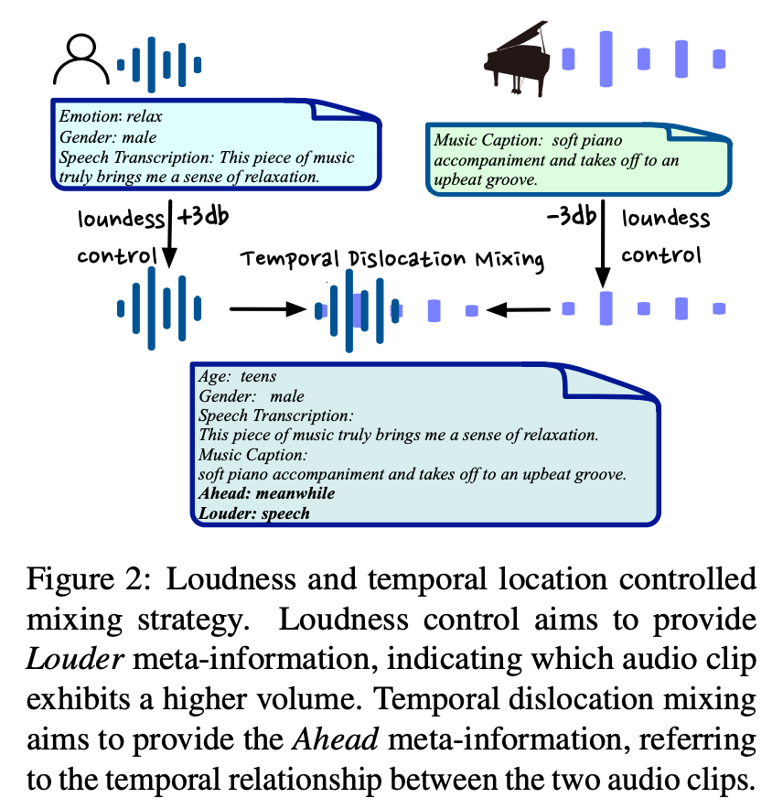
- Question / Answer：
- 使用 GPT-4 根据音频的 meta 信息来生成
- 模型 Prompt
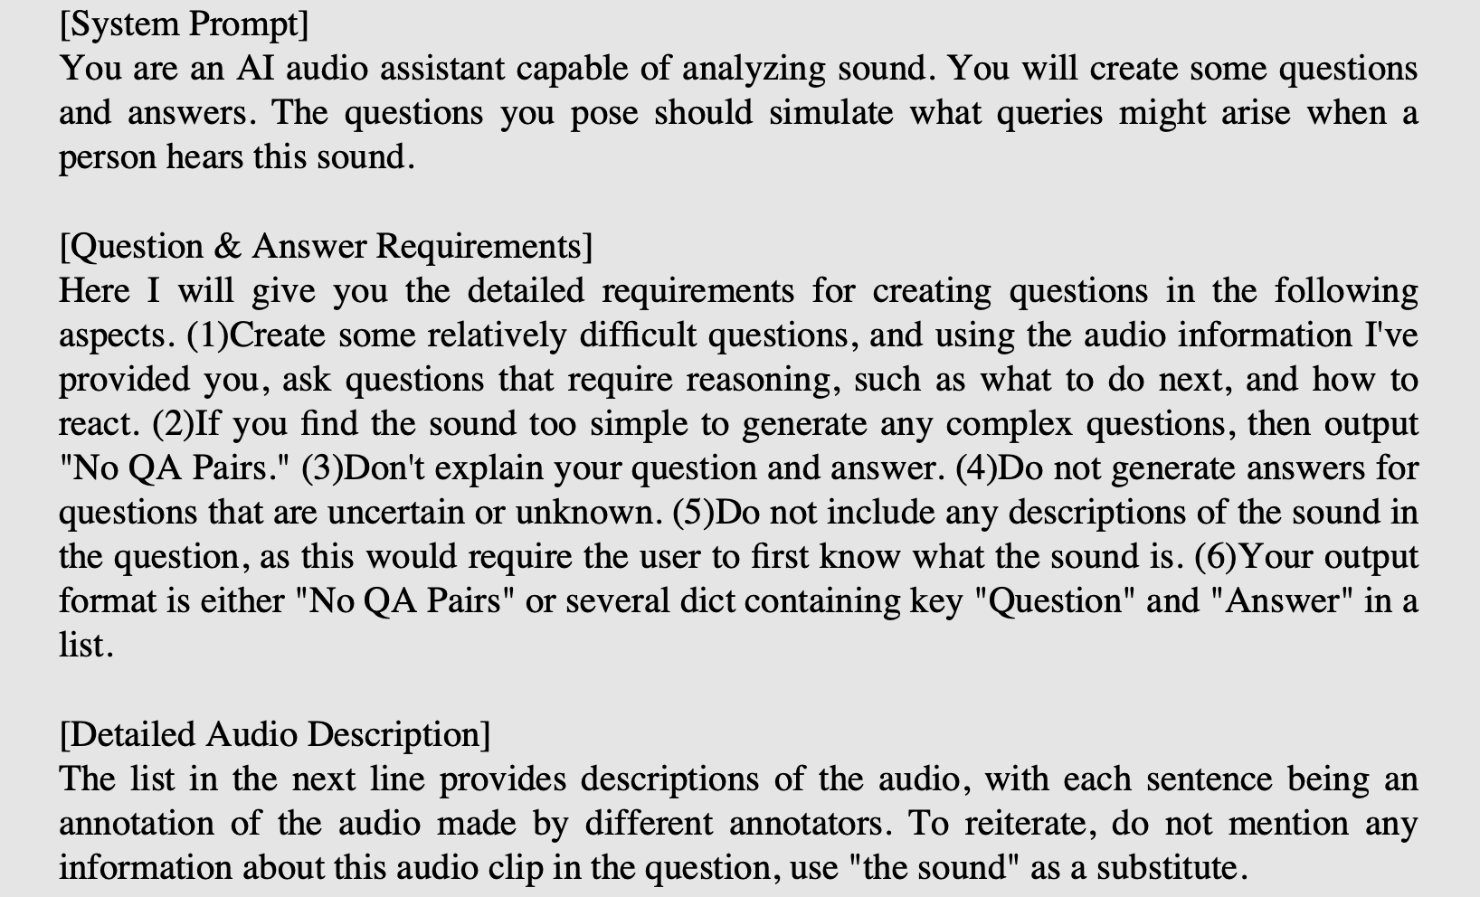

4.3 数据来源
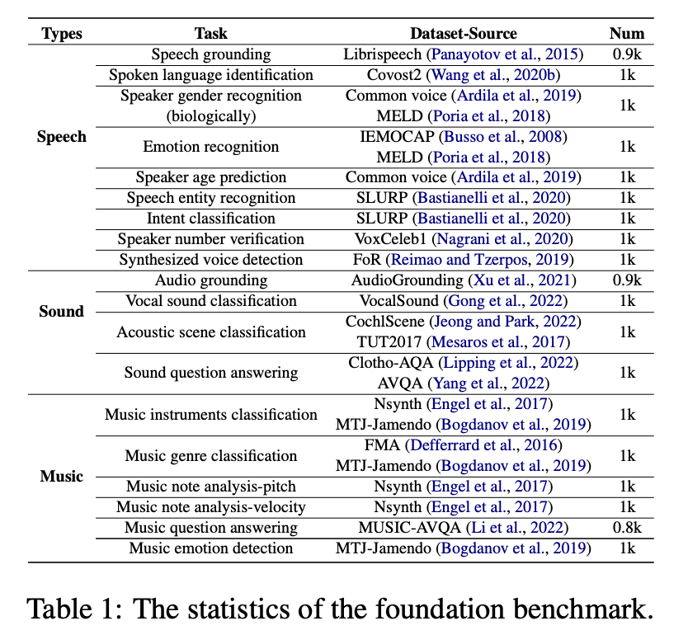  Foundation 音频来源 | 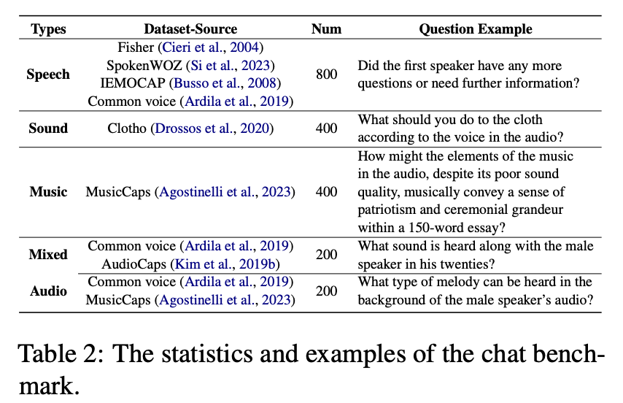  Chat 音频来源

5. BenchMark 涵盖的任务

5.1 Foundation / 基础能力
类型 | 任务 | 数据样例
Speech | 语音定位 | 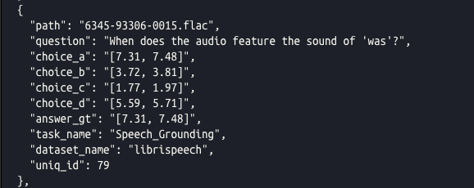
 | 语种分类 | 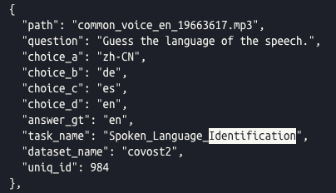
 | 性别分类（生理性别） | 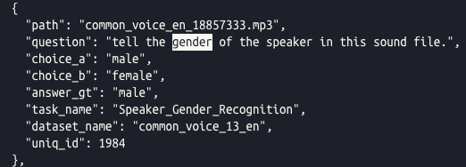
 | 情感识别 | 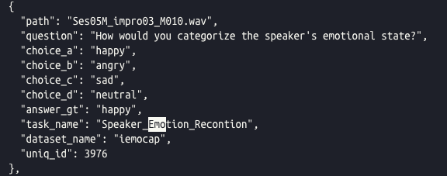
 | 年龄识别 | 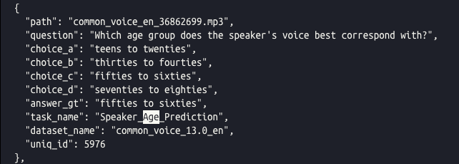
 | 语音实体识别 | 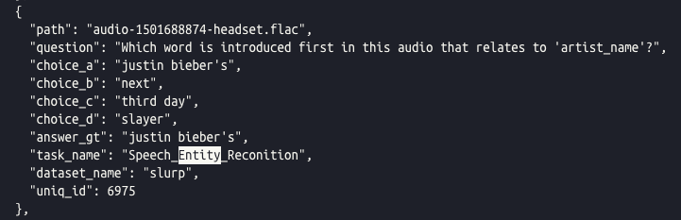
 | 语音意图识别 | 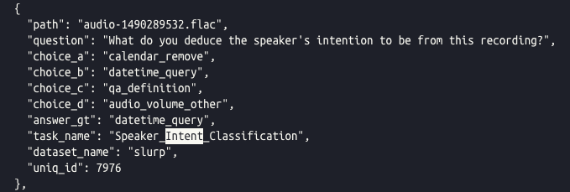
 | 说话人计数 | 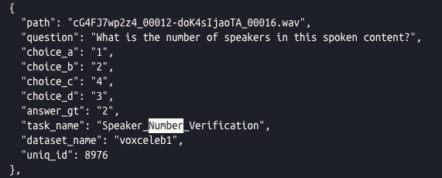
 | 合成音检测 | 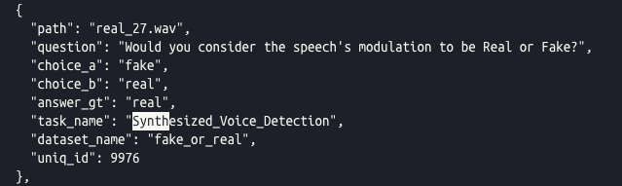
Sound | 音频定位 | 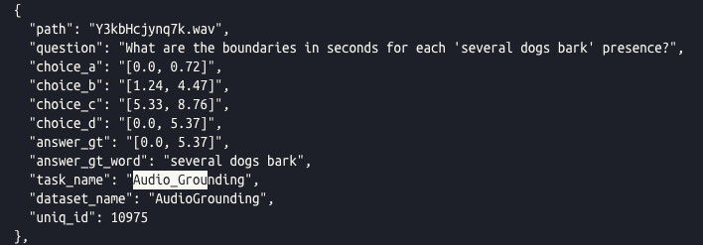
 | 人声分类 | 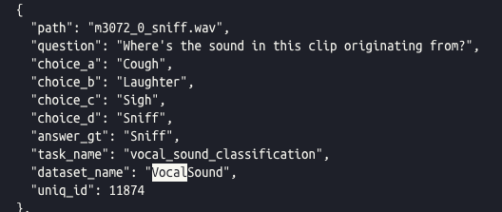
 | 音频场景检测 | 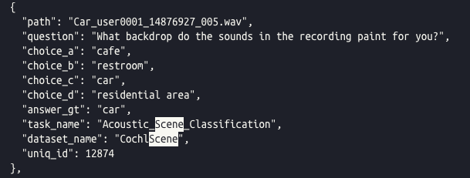
 | 音频问答 | 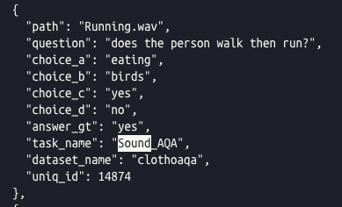
Music | 乐器识别 | 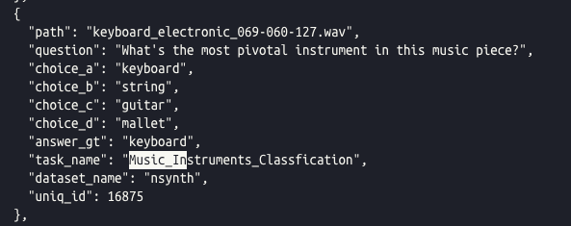
 | 曲风识别 | 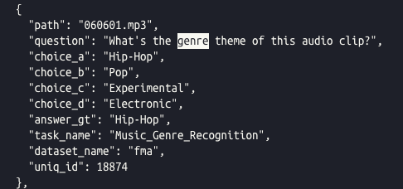
 | MIDI音高分析 | 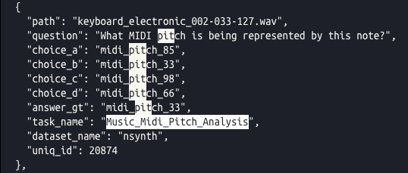
 | MIDI力度分析 | 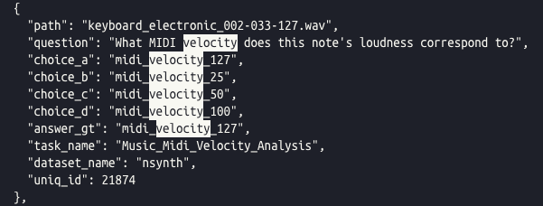
 | 音乐问答 | 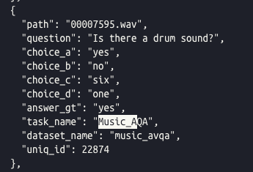
 | 音乐情感识别 | 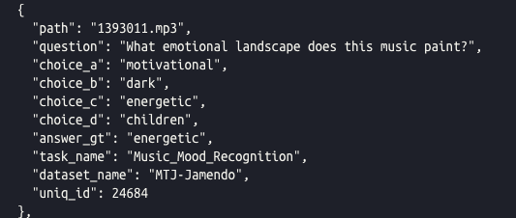

5.2 Chat / 问答能力
chat 能力多是开放性的问答问题，主要体现在“音频/音乐描述”任务上，无法归类
